Jean Karst
CS 340
Project 2

README File

Project Overview
Grazioso Salvare is an international rescue animal training organization that identifies dogs suitable for specialized search-and-rescue training. This project implements a full-stack web dashboard that enables users to interact with animal shelter data stored in a MongoDB database. The dashboard allows users to filter dogs by rescue type and visualize relevant data through an interactive table, charts, and a geolocation map.
The application follows the Model-View-Controller (MVC) design pattern:
- Model: MongoDB database
- View: Dash dashboard interface
- Controller: Python CRUD module connecting the interface to the database

Required Functionality
The dashboard provides the following functionality:
- Displays an unfiltered dataset of animals from the Austin Animal Center
- Allows users to filter dogs based on rescue training suitability:
  - Water Rescue
  - Mountain/Wilderness Rescue
  - Disaster/Individual Tracking
  - Reset (All Data)
- Dynamically updates the data table based on selected filters
- Displays a chart showing the most common breeds in the current dataset view
- Displays a geolocation map centered on the selected animal
- Includes the Grazioso Salvare logo and a unique identifier

Dashboard Screenshots

Starting State — Reset (All Data)

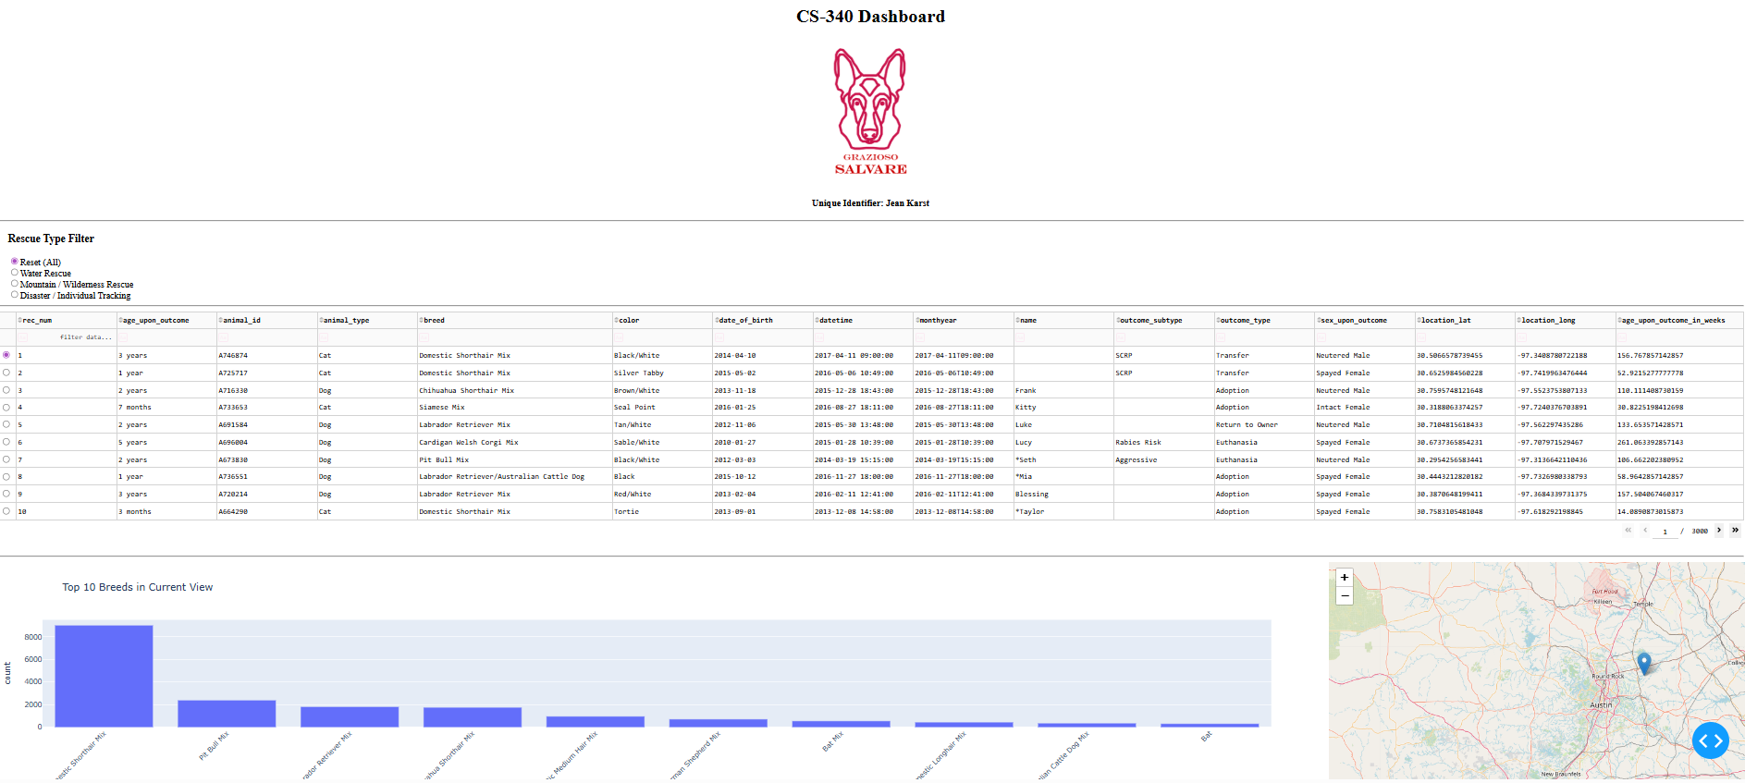

Water Rescue Filter Applied

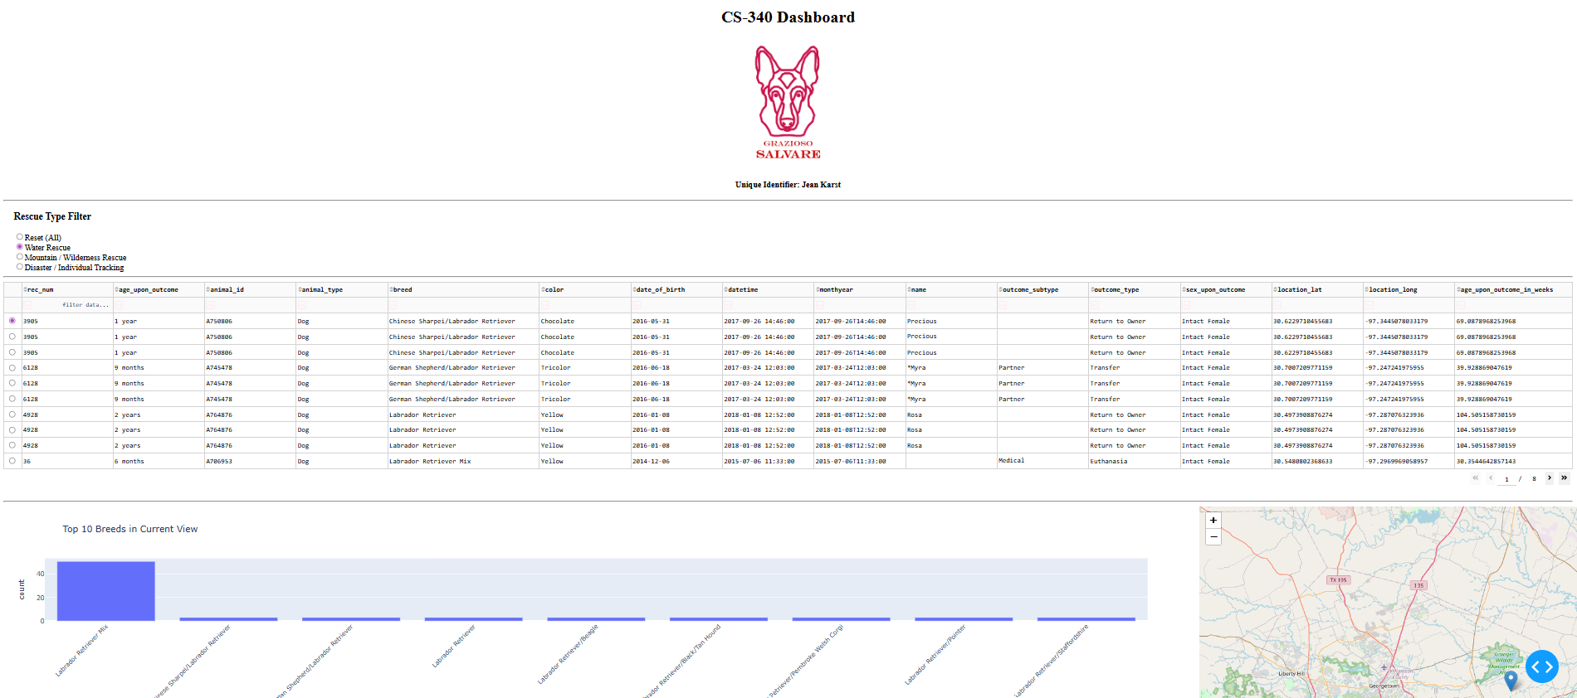

Mountain/Wilderness Rescue Filter Applied

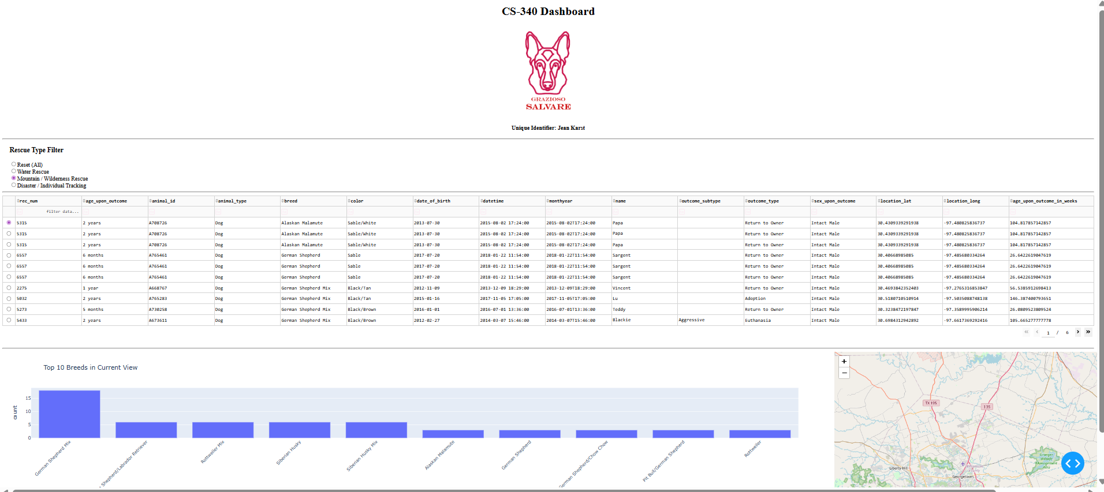

Disaster/Individual Tracking Filter Applied

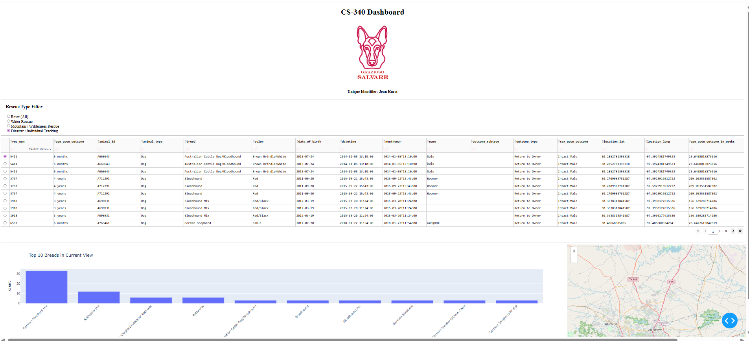

Tools Used and Rationale

Python
Python was used as the primary programming language due to its extensive support for data analysis, database interaction, and web application development. Its readability and large ecosystem make it ideal for rapid development of data-driven applications.

MongoDB
MongoDB was selected as the database system because it is a NoSQL document database capable of storing large, flexible datasets without requiring a rigid schema.
Key advantages include:
- Stores data in JSON-like documents (BSON), which map naturally to Python dictionaries
- Supports flexible queries and indexing
- Handles large datasets efficiently
- Easily integrates with Python using the PyMongo library
- Well-suited for rapidly changing or semi-structured data
MongoDB served as the Model component in the MVC architecture.

PyMongo
PyMongo is the official MongoDB driver for Python and was used to implement CRUD operations (Create, Read, Update, Delete). The custom CRUD module built in Project One uses PyMongo to connect the dashboard to the database securely.

Dash Framework
Dash is a Python framework for building analytical web applications without requiring JavaScript.
Dash provides:
- Interactive UI components
- Real-time updates through callbacks
- Integration with Plotly for data visualization
- Support for maps and tables
Dash serves as both the View and Controller:
- View: Layout components (tables, charts, map, filters)
- Controller: Callback functions that update components based on user input

Plotly Express
Plotly Express was used to generate interactive charts. It allows quick creation of visualizations that update dynamically with filtered data.

Dash Leaflet
Dash Leaflet was used to create the geolocation map component. It displays the location of selected animals using latitude and longitude coordinates.

Resources and Software Used
- Python 3.x
- MongoDB
- PyMongo
- Dash Framework
- Plotly Express
- Dash Leaflet
- JupyterLab / Codio development environment
Helpful documentation:
- https://www.mongodb.com/docs/
- https://pymongo.readthedocs.io/
- https://dash.plotly.com/
- https://plotly.com/python/
- https://leafletjs.com/

Steps Taken to Complete the Project
- Developed a MongoDB database containing animal shelter data
- Created a Python CRUD module to perform database operations
- Loaded shelter data into MongoDB
- Designed the dashboard layout using Dash components
- Implemented interactive filtering controls
- Connected filters to MongoDB queries through callback functions
- Created an interactive data table to display results
- Implemented a dynamic chart showing breed distribution
- Implemented a geolocation map displaying animal locations
- Integrated the Grazioso Salvare logo and unique identifier
- Tested functionality for each filter state
- Captured screenshots demonstrating successful operation

Challenges Encountered and Solutions

Challenge 1 — Database Authentication
Connecting to MongoDB required proper credentials and authentication configuration. Initial attempts resulted in authentication errors.
Solution: Verified the correct username, password, and authentication database and used secure input methods for credentials.

Challenge 2 — Handling MongoDB ObjectID Values
MongoDB returns an _id field of type ObjectID, which is not directly compatible with the Dash DataTable component.
Solution: Removed the _id column from the dataset before displaying it in the table.

Challenge 3 — Synchronizing Dashboard Components
Ensuring that the data table, chart, and map updated simultaneously required careful configuration of Dash callback functions.
Solution: Used Dash’s reactive callback system with shared inputs to ensure all components respond to filter changes.

Challenge 4 — Map Visualization
Displaying geographic coordinates correctly required identifying the correct latitude and longitude fields and ensuring valid data was present.
Solution: Verified dataset fields and implemented fallback handling for missing values.

Conclusion
This project successfully delivers a fully functional dashboard that allows Grazioso Salvare to identify and analyze dogs suitable for search-and-rescue training. The application integrates database operations, interactive filtering, data visualization, and geolocation mapping into a user-friendly interface.
The dashboard is designed to be maintainable, scalable, and adaptable for similar organizations in the future.

